# S E R V E R S I D E I N T E R N E T P R O G R A M M I N G

# R E P O R T



# CREATE BY:

1. **Inria Altje Kalalo**
2. **Sheryl Sharon Kaparang**
3. **Salwa As-Saffa Sahante**

**PRESIDENT UNIVERSITY**

**ACADEMIC YEAR 2024-2025**

# SIMPLE REPORT

# A. Index home Page - Customer/User

# 

1. Press Rent Car is a professional car rental service committed to delivering convenient, reliable, and affordable vehicle rental solutions. With a focus on customer satisfaction and ease of access, the company offers a wide selection of vehicles for both personal and business use. The website features user-friendly navigation with key sections including Home, About Us, Car Listings, FAQs, and Contact Us, ensuring visitors can easily explore available services and vehicles.

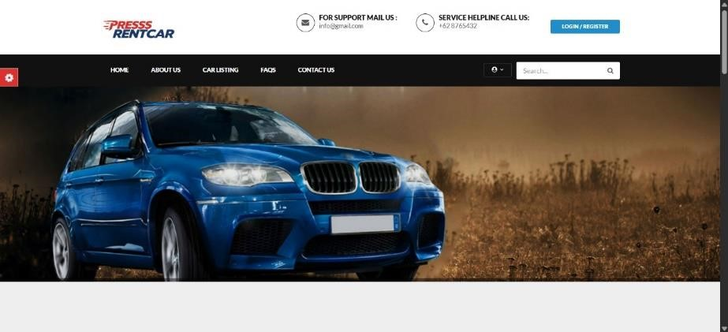

1. The login page allows users to sign in with their email and password. It is simple and easy to use. New users can click “Signup Here” to create an account, and there is also a “Forgot Password?” link to recover access. This page helps customers manage their bookings and personal information securely.

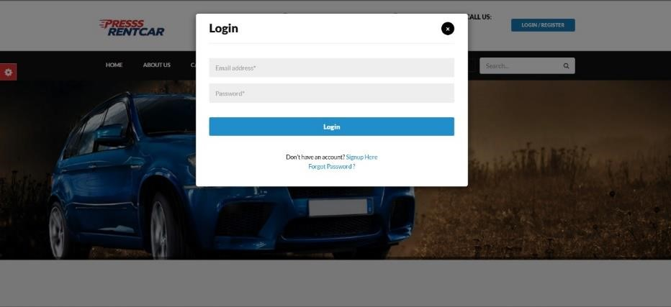

1. The display when the customer/user logs in. they can immediately compound the car and can provide testimonials, and there is a menu of booking history, testimonials and profile settings.

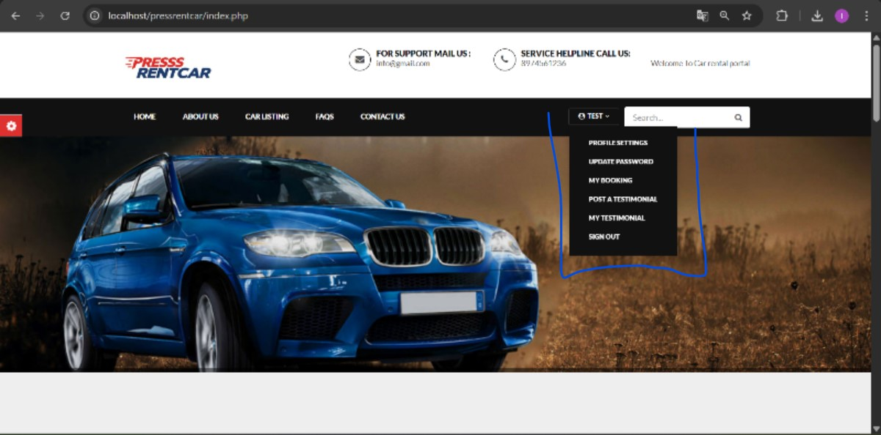

1. PRESSS RentCar offers a wide variety of vehicles, from compact cars to full-size sedans. All our vehicles come equipped with air conditioning, power steering, and electric windows. We only purchase from official dealerships to ensure the best quality for our customers.

We are not affiliated with any specific automaker, allowing us to provide a diverse selection of vehicle models. Whether you're looking for a new or used car to rent, we've got you covered.

Our mission is to be recognized globally as a leader in car rental services, delivering efficient and customer-focused solutions for both individuals and businesses.

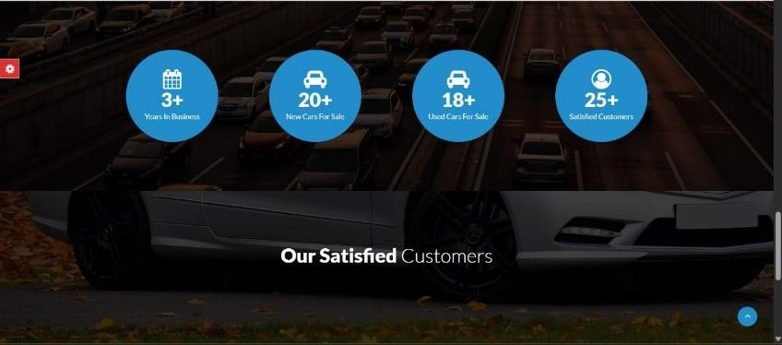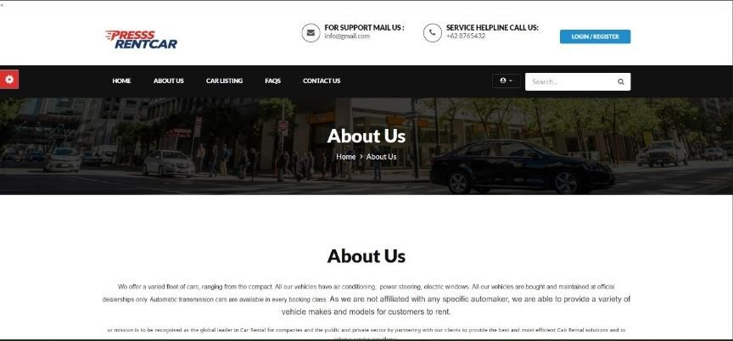

1. A Car Listing System is a platform or module designed to display and manage a catalog of cars available for rent, sale, or lease. It allows users to browse, search, and view detailed information about each car. The system is typically used in applications like car rental services, car dealerships, or peer-to-peer vehicle marketplaces.

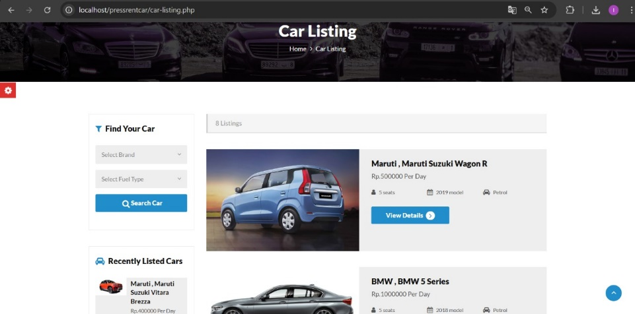

1. The ContactUs page is used to allow visitors or customers to get in touch with the website administrators. It typically provides a contact form and official contactdetails.

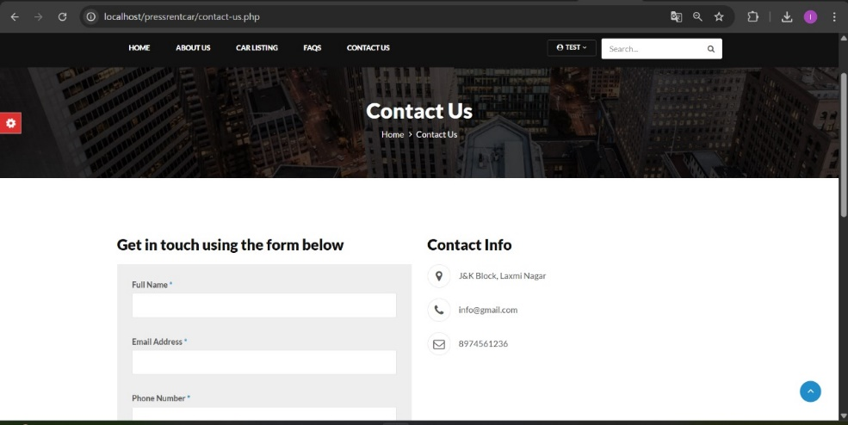

1. When a customer submits a testimonial (usually through a form in their user dashboard or on a "Submit Testimonial" page), and it gets approved by the admin, the testimonial will then be shown publicly on the homepage in the “Our Satisfied Customers**”** section.

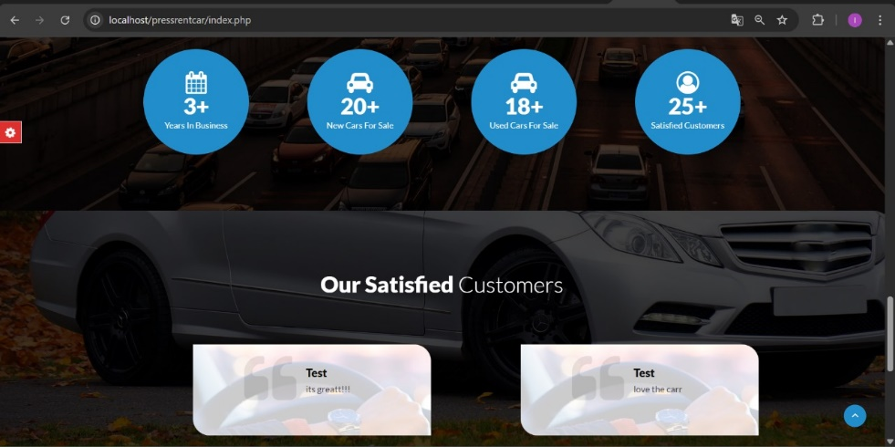

**B. Admin Panel**

1. The Admin Sign-In feature is a secure gateway that allows authorized administrators to access the backend dashboard of the system. This dashboard is typically used for managing car listings, users, bookings, and other system settings.

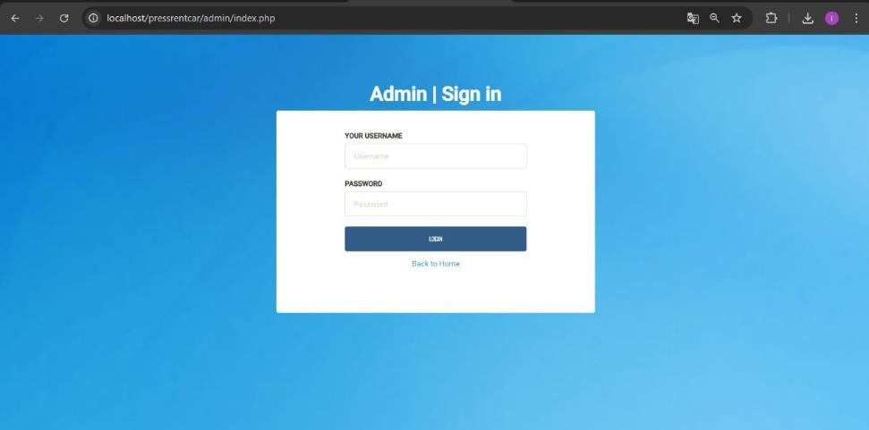

1. The Admin Dashboard is a central control panel designed for system administrators. It provides secure access to manage all platform data and activity — including car listings, users, transactions, reports, and system settings.

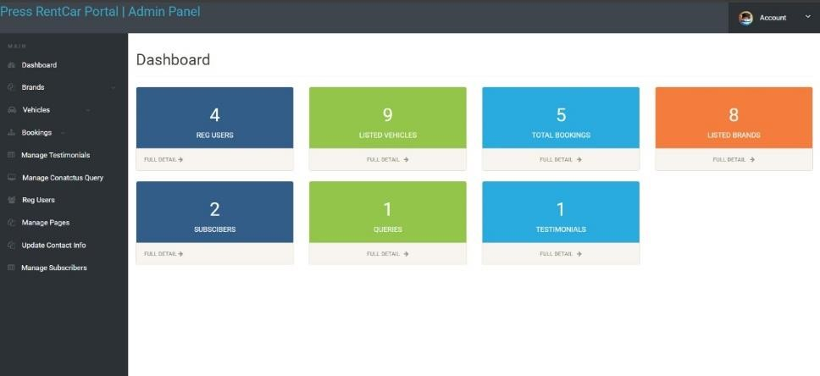

1. Besides that there are also manage testimonials, manage contact us queries, reg users, manage pages, update contact info and subscribers. here the admin can easily manage all testimonials and subscribers and contact.

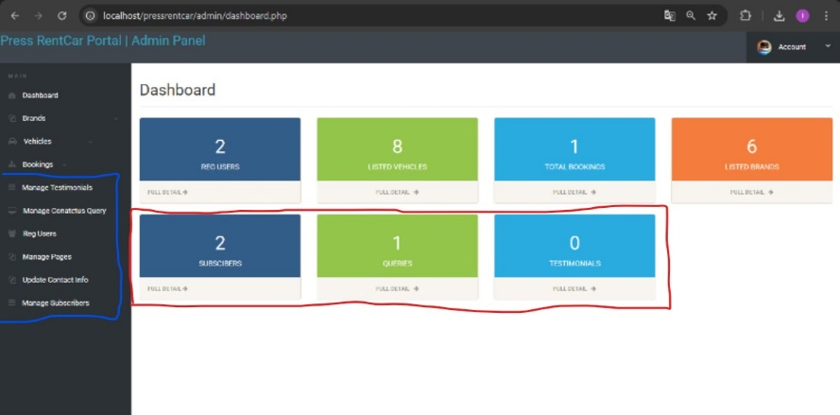

1. This image displays the "Registered Users**"** section from the Admin Panel of the Press RentCar Portal system. This feature allows the administrator to view, manage, and keep track of all users who have signed up on the platform.

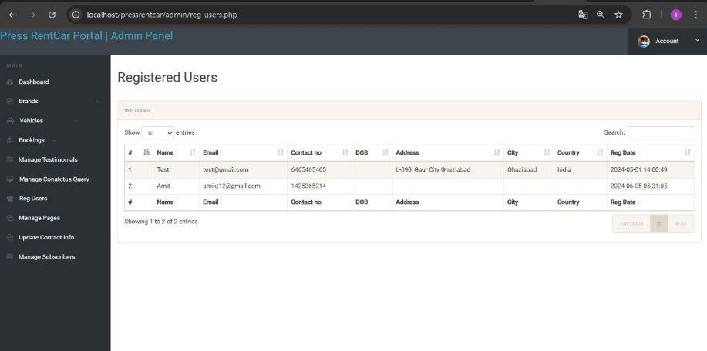

1. View manage pages. admin can edit page views such as terms and conditions, privacy and policies etc.

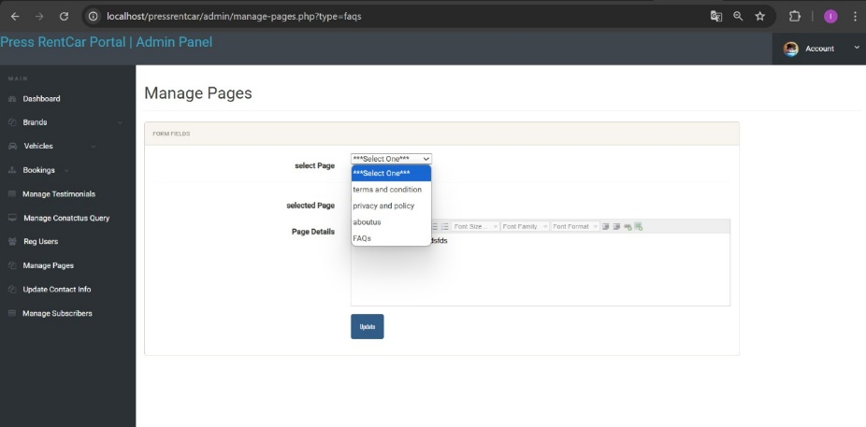

1. The New Bookings module allows administrators to view, verify, and manage incoming car rental requests submitted by customers. This section acts as a central queue where pending reservations are reviewed before approval or rejection.

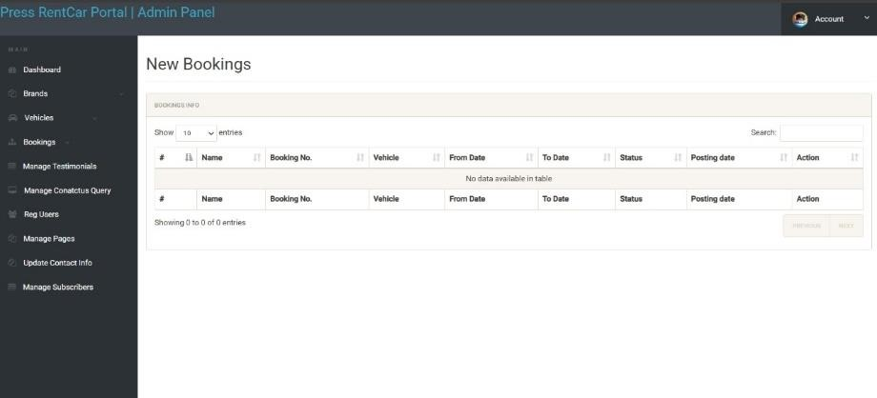

1. The Confirmed Bookings section is a vital component of any car rental admin dashboard. It displays all bookings that have been reviewed and approved by an administrator. Once a booking is confirmed, the car is officially reserved for the specified dates, and it becomes unavailable to other customers during that period. This module helps the admin monitor and manage all active and upcoming rentals efficiently and ensures proper coordination between bookings, vehicle availability, and customer communication.

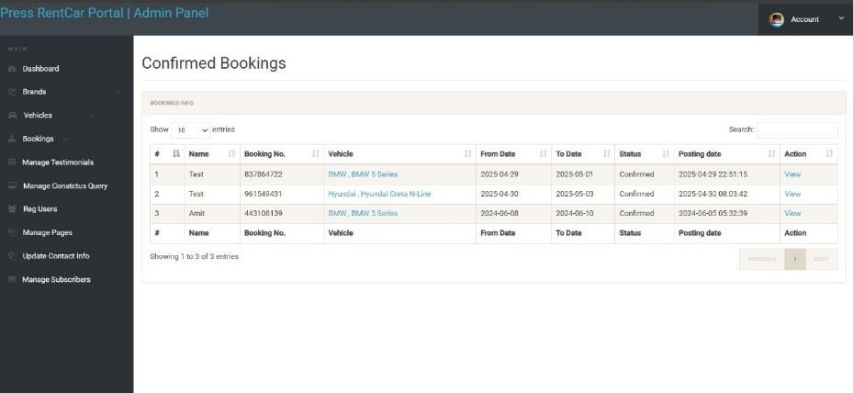

1. The Canceled Bookings section allows administrators to view and manage all reservations that have been canceled — either by the customer or by an admin. This module ensures transparency and record-keeping for all booking cancellations, including reasons, timestamps, and affected vehicles. Proper management of canceled bookings helps avoid confusion, track customer behavior, and maintain accurate availability of the vehicle fleet

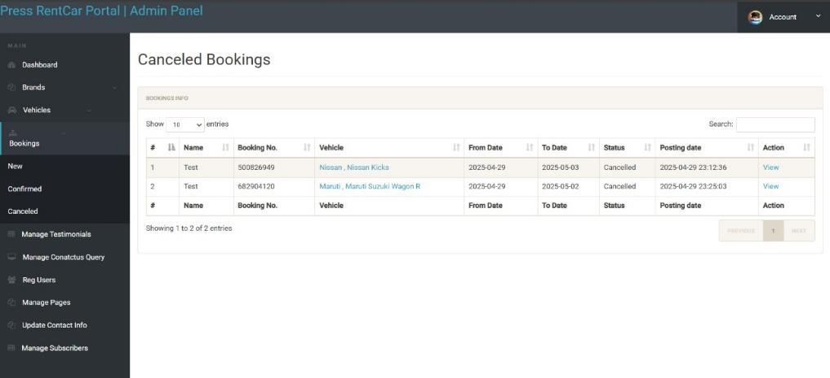

1. Manage Vehicles is a feature that allows the admin to view, add, edit, and delete the cars available for rent in the system.Its purpose is to ensure that vehicle information such as title, brand, rental price, fuel type, and model year is always up-to-date and accurate.

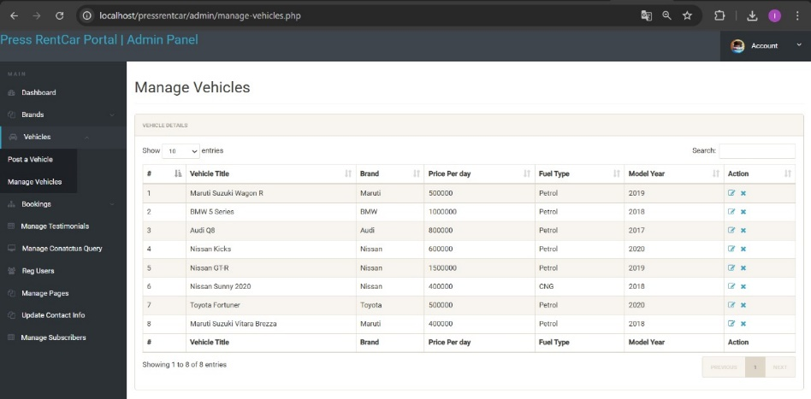

1. admin panel view of the manage testimonials section, the admin can decide to display or not display testimonials to the Main page. active means the testimonial is currently appearing on the Main page, in

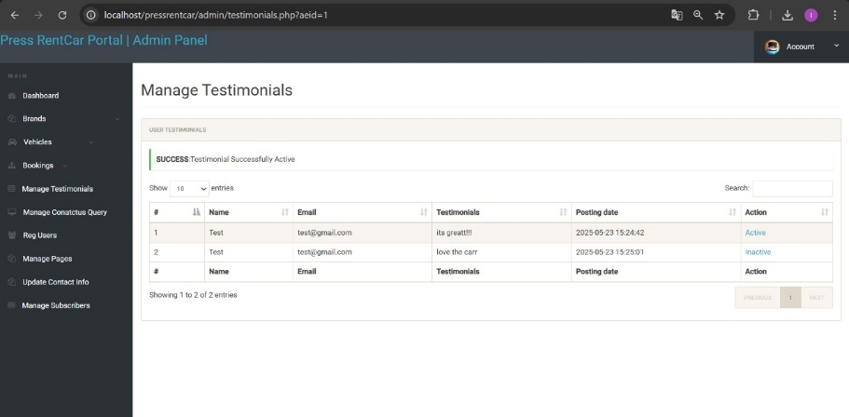

1. This image shows the “Update Contact Info” section from the Admin Panel of the Press RentCar Portal. This feature allows administrators to modify and maintain up-to-date contact information for the platform, ensuring users can reach the company easily.

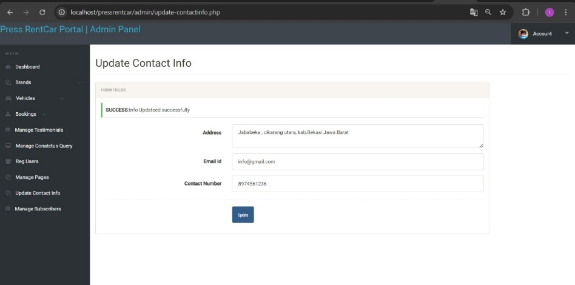

1. This image displays the “Manage Subscribers**”** section from the Admin Panel of the Press RentCar Portal. This page provides administrators with a clear interface to view and manage email subscribers who have opted in to receive updates or newsletters.

